Create the feature branch

|  |  |
| --- | --- |
| $ git checkout -b feature | Creates a branch on your local machine named “feature” and switches to that branch. |
| $ git push –-set-upstream origin feature | Copies the (empty) branch to the remote repository and names it “feature”. |

* This will push the branch **you currently have checked out**. If you aren’t sure which branch is checked out, see below.   
*(This also assumes you named your remote “origin” per convention.)*

|  |  |
| --- | --- |
| $ git branch | shows all branches on your **local** machine |
| $ git checkout <name> | switches to <name> branch |

Updating Progress

From here, work as normal, making commits to your branch as needed. Your commits will not affect other branches.

|  |  |
| --- | --- |
| $ git status | Lists all files which have been changed. |
| $ git add <file> | Stages <file> to be added to the remote repository with the next commit |
| $ git add -A | Stages **all changes** |
| $ git add . | Stages new files **but** **not files which have been deleted** |
| $ git add -u | Stages changes and deletions **but not new files** |
| $ git commit -m “<message>” | Commits the files locally with your **descriptive** message. |
| $ git push | Pushes your local commits to the remote repo.  (You don’t have to do this after every commit.) |

Peer Review

When your feature is working and you’re ready for peer review.

1. Push your latest changes to the remote repository.
2. On the GitHub website, navigate to “Pull Requests”. It is the third tab on the horizontal menu.

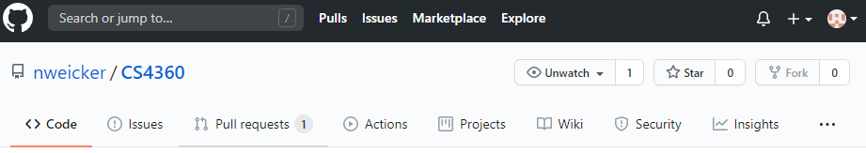

1. Click the button labeled “New Pull Request” on the right-hand side.
2. Select “master” as the base branch and “feature” as the compare branch.
3. Click the button labeled “Create Pull Request”.
4. In the text box, write a brief description of the feature such as the desired behavior.
5. **Do not merge / approve your own pull request!**
6. **Another** team member **who did not work on the feature** will now pull the feature to their machine and test it.

|  |  |
| --- | --- |
| $ git branch -r | Lists all branches on the **remote** repository. |
| $ git checkout <remote_branch> | Clones <remote_branch> to your local machine. |
| $ git branch -d <local_branch> | Deletes the local branch from your machine. |

1. If the feature works as intended, the peer reviewer will confirm the merge to master through GitHub.